**EX.NO:1**

**DATE:**

**TOTAL ACHIEVED VALUE BASED ON THE SALESMAN AND PRODUCT**

Using the Array concepts in Excel find the Total Archived value based on the Salesman and Product for the below data.

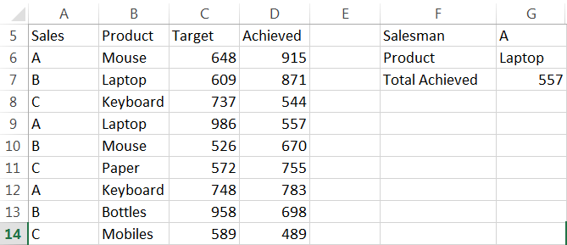

**Aim:**

To find the total archived value based on the Salesman and Product for the given data using the array concepts in excel.

**Algorithm:**

**Step 1:** Open MS-EXCEL using the below menu, we can open the MS Excel.

**Start -> All Programs -> Microsoft Office -> MS-Excel.**

**Step 2:** Enter the given Salesman Name in Column A, Product in column B, Target Sales in Column C and Sales Achieved detail in Column D in the excel sheet.

**Step 3:** As an Input Parameter, enter the Salesman Name “A” in Cell G5

**Step 4:** Enter the Product details cell G3, for an example enter as “laptop”.

**Step 5:** To find the value achieved by salesman “A” for the Product “laptop”, Enter the below formula in cell B4 as below

**=SUM (IF ((A3:A11=G2)*(B3:B11=G3), D3:D11))**

**Step 6:** Alter entering the above formula in cell B4 and Click “**Ctrl + Shift + Enter**” we will get the expected output.

**Step 7:** We will get the expected output **557** in the cell B4.

**Step 8:** With the help of this formula, we can find the total value achieved by different salesman for different products. Save and Close the File.

**Output:**

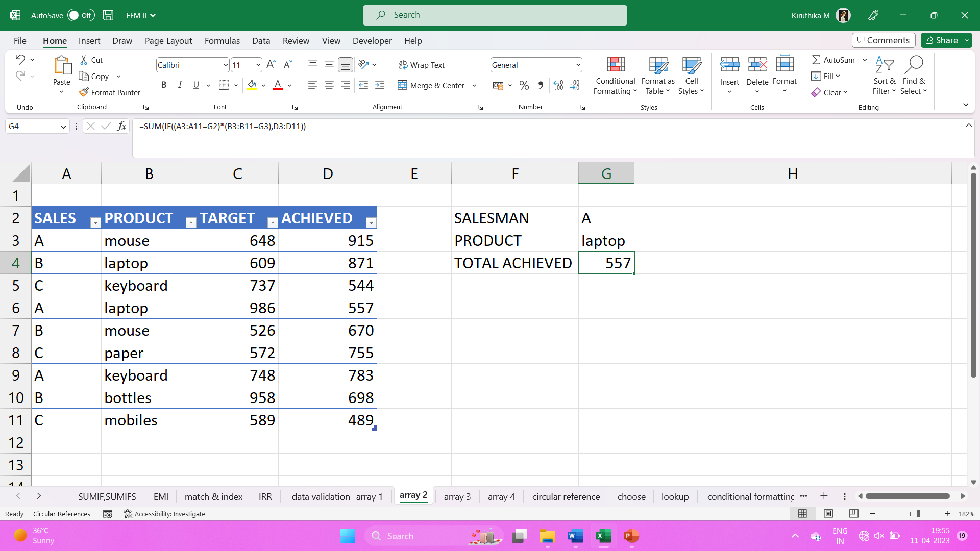

**EX: NO: 2**

**DATE:**

**SUM OF OUTPUT OF A PERSON A**

**Calculate the Sum of Output of a person A, for the month of Jan, Feb and Mar using the below data dynamically.**

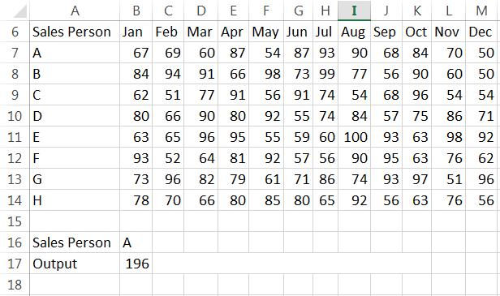

**Aim:** To calculate the sum of output of a person A, for the month Jan, Feb and Mar using the given data, with the help of MS- EXCEL.

**Algorithm:**

**Step 1:** Open MS-EXCEL by using the command start- all programs- Microsoft office- MS-Excel

**Start -> All Programs -> Microsoft Office -> MS-Excel.**

**Step 2:** Type the given salesperson field and month’s field with its values.

**Step 3:** In cell B16 type as salesperson and in cell C16 type as A and in cell B17 type as output.

**Step 4:** To find the sum of sales made by salesperson A for the month Jan, Feb and Mar type formula as below:

**{=SUM (VLOOKUP (C16, A7:M14, {2, 3, 4}, 0))}**

**Step 5:** Click **“Ctrl+ Shift+ Enter”** buttons.

**Step 6:** Now you can find the value **196**. With the help of this formula you can dynamically calculate the sales amount of a sales person for first 3 months.

**Output:**

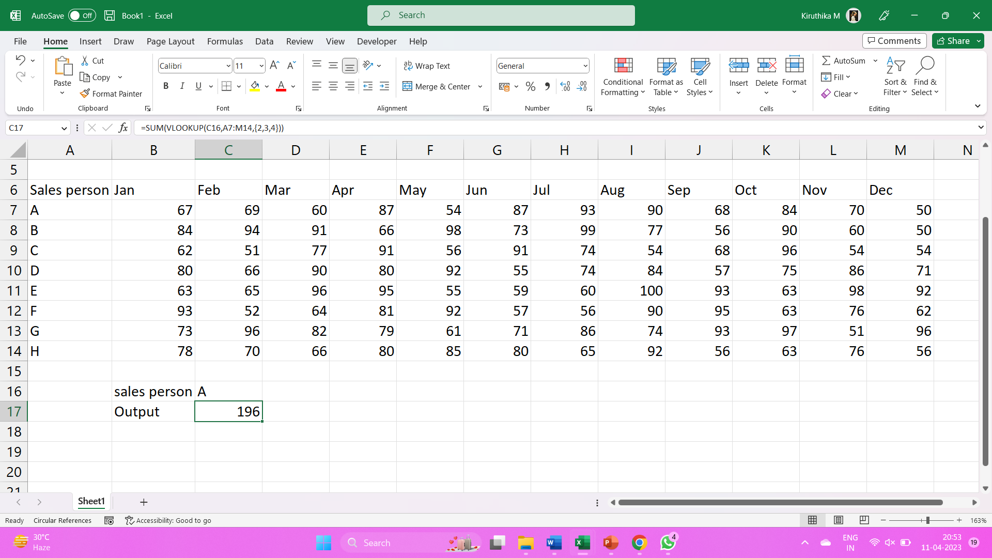

**EX.NO: 3**

**DATE:**

**CIRCULAR REFERENCE USING ARRAY CONCEPTS**

**Aim:** To simulate the circular reference for the given data using array concepts in excel.

**Algorithm:**

**Step 1:** Open MS-EXCEL using the below menu, we can open the MS Excel.

**Start -> All Programs -> Microsoft Office -> MS-Excel.**

**Step 2**: Enter the Sales and Expense details in the cell B6 and B7.

**Step 3**: Enter the Tax details in the cell B9

**Step 4**: Enter the profit details formula as below:

**= Sales – Expenses – Other Expenses - Tax**

**= C6 – C7 – C9 – C9**

**Step 5:** Enter the formula for Other Expenses as below:

**= 10% of Profit**

**= (10/100) * C10**

**Step 6:** While entering the formula and Profit and Other Expenses, the Other Expense is not calculated.

**Step 7:** For that we need to enable the Circular Reference option using the below menu:

**File –> Options –> Formulas – Enable iterative calculation**

Check box to be clicked.

**Step 8:** We will get the expected outcome.

**OUTPUT:**

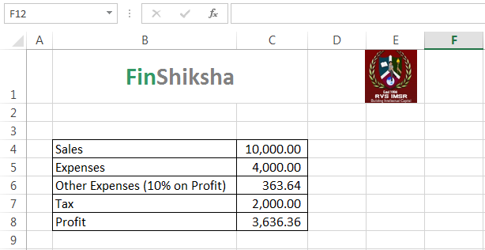

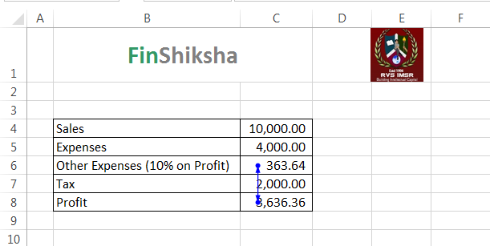

**EX.NO:4**

**DATE:**

**THERMOMETER CHART**

**Generate the below Thermometer Chart for the following data:**

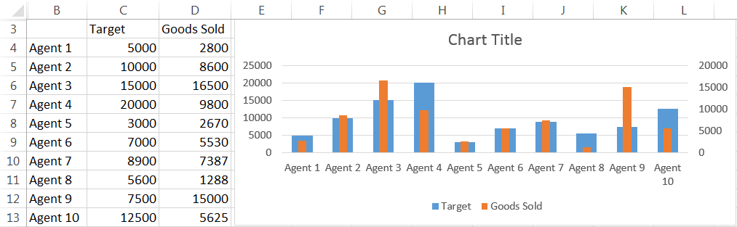

**Aim: T**o generate Thermometer chart for the given data using MS Excel.

**Algorithm:**

**Step 1:** Open MS Excel by using the command start – All Programs – Microsoft office – MS Excel.

**Start -> All Programs -> Microsoft Office -> MS-Excel**

**Step 2**: Type the given Agent name, Target and Goods sold fields and its values.

**Step 3**: Select the values of Agents, Target and Goods sold. Create a Column chart.

**Step 4**: To create a Column chart click

**Insert -> Column chart.**

**Step 5**: Now you can find two different bar charts for each agent. The Blue bar represents Target and the Orange bar represents Goods sold.

**Step 6**: Select the goods sold bar and right click the mouse. A popup menu appears. Select “Format Data Series” option from the menu.

**Step 7**: Enable **“Secondary axis”** radio button. Now you can find the orange bar overlaps the blue bar.

**Step 8**: Adjust its size by using “**gap width”** option to get the shape of Thermometer.

**Step 9**: Type the chart title as “Thermometer Chart”.

**Output:**

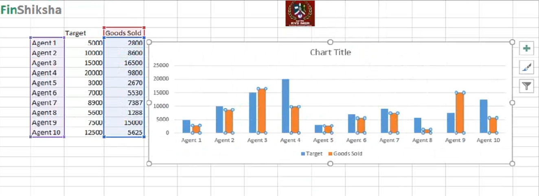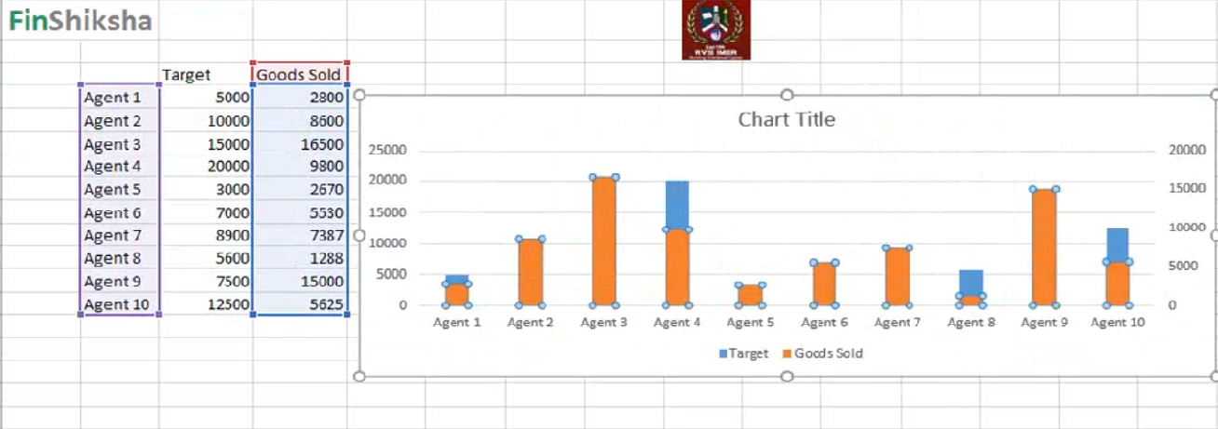

**EX.NO: 5**

**DATE:**

**Bullet Chart**

**Aim: Generate the Bullet Chart for the below data:**

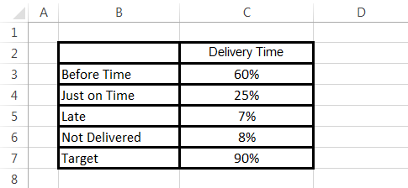

**Algorithm:**

**Step 1:** Open MS-EXCEL using the below menu:

**Start -> All Programs -> Microsoft Office -> MS-Excel**

**Step 2:**  Enter the data into the worksheet.

**Step 3:** Select the entire data and use the below menu to create a Bar Chart

**Insert -> Column Chart -> 2D Stacked Column Chart**

**Step 4:**  Using the menu change the Chart Type as Stacked Column Chart

**Step 5:** Choose the Target Data Value and Change Series Chart Type -> Select Target Data Point and changed the Chart type as Line chart with Markers

**Step 6:** Select the Target Data Point and right click and Format Data Series menu. In that select Fill and Marker option, select the Built-in option and select the Symbol we want and select the Marker Size.

**Step 7:** Now we will get the Expected Results.

**OUTPUT:**

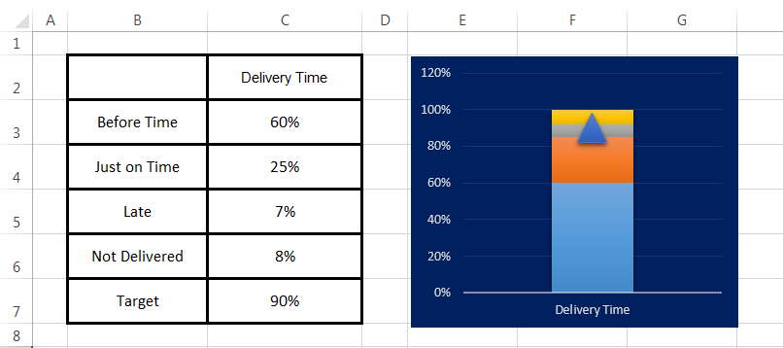

**EX.NO:6**

**DATE:**

**DYNAMIC LINKED LEGEND CHART**

**Create the below Dynamic Linked Legend Chart for the following data.**

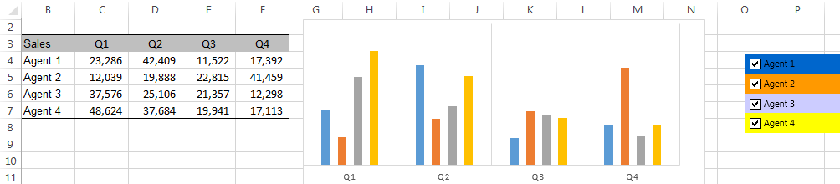

**Aim: T**o create Dynamic Linked legend chart for the given data using MS Excel.

**Algorithm:**

**Step 1:**  Open MS Excel by using the command start – All Programs – Microsoft office – MS Excel.

**Start -> All Programs -> Microsoft Office -> MS-Excel**

**Step 2:** Type the given Sales of agents for different quarters ie., Q1, Q2, Q3, Q4

**Step 3:** Select the values of sales, Q1, Q2, Q3 and Q4. Paste the values in another worksheet.

**Step 4:** Create checkbox for each Agents.

**Step 5:** To create a checkbox, use the command

**Developer –> Insert –> Form controls –> Checkbox.**

**Step 6:** Select the check box, drag it int the sheet. Name the check box as “Agent1”. Like this, create checkbox for Agent 2, Agent 3 and Agent 4.

**Step 7:** Assign a cell as cell link, Right click the mouse button and do as follows

**Format control –> Cell link –>Select a cell.**

**Step 8:** Set the cell A4 as a cell link for Agent 1 checkbox, A5 for Agent 2, A6 for Agent 3 and A7 for Agent 4.

**Step 9:** In the cell which is referred as cell link, it shows TRUE when the checkbox is enabled.

**Step 10:** To find the value of Agent 1 for Q1 type formula as below:

**=IF (A4=TRUE, Data! C4, NA())**

**Step 11:** By using the above formula, find the values of sales for all the Agents in different quarters.

**OUTPUT:**

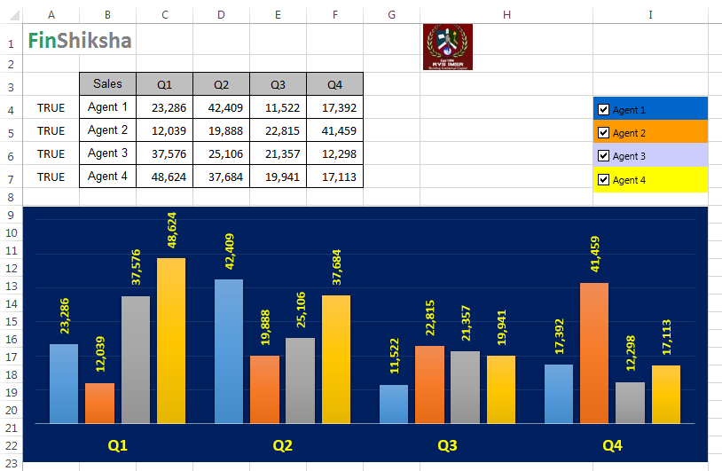

**EX.NO: 7**

**DATE:**

**Dynamic Graph Control Chart**

**Aim: Generate the dynamic graph control chart for the below given data:**

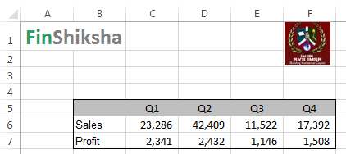

**Algorithm:**

**Step 1:** Open MS-EXCEL by using the command start- all programs- Microsoft office- MS-excel.

**Start -> All Programs -> Microsoft Office -> MS-Excel.**

**Step 2:** Enter the above data in the Excel.

**Step 3:** Using Developer Menu, select the Form Control and pick the Check Box control and place it in the excel sheet.

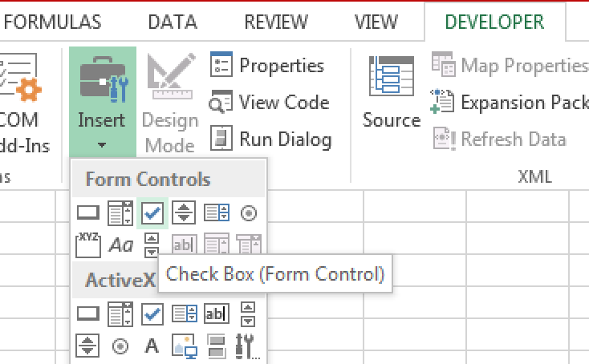

**Step 4:** Change the Label as “Agent 1”

**Step 5:** Right click the control and select the Format Control Menu -> Control tab select the cell link for the Unchecked option as A4. This means while selecting the check box checked then the value “TRUE” will be placed in the cell A4. Similarly do the same steps for Profit.

**Step 6:** Use below if condition to link the values with checkboxes and show the Agent 1 Sales data or show as “#NA”.

**=IF ($A4=TRUE, ‘Data 1'! C6, NA ())**

**Step 7:** Copy the above formula to Q2, Q3 and Q4 and check the values are shown as well as NA shown for unchecked option chosen.

**Step 8:** Follow the same steps for Profit

**Step 9:** After populating the data select the Data Range and use the below menu to generate the column chart.

**Insert - > Charts -> 2D Column Charts**

**Step 10:** Now the Sales and Profit will be shown as Column data bars

**Step 11:** Select the Profit Data Points and select “Change Series Chart Type” menu

**Step 12:** We can see the Chart Type and Secondary Axis check Box. Change the Chart type of Profit into “Line Chart” and click the Secondary Axis check box

**Step 13:** Select Profit and Sales Data Points and enable the data labels.

**Step 14:** We will get the expected Output.

**OUTPUT:**

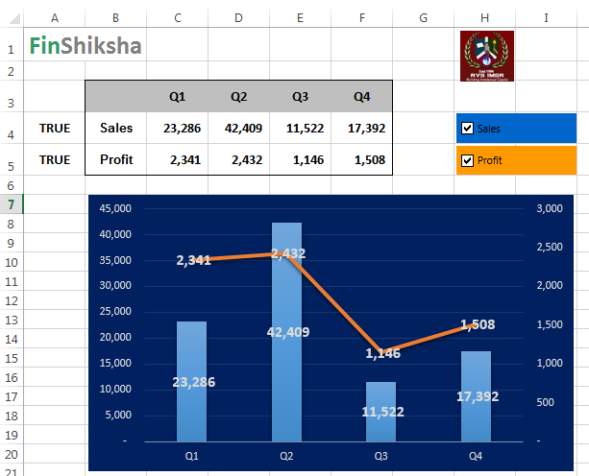

**EX.NO: 8**

**DATE:**

**Dashboard Creation**

**Create a Dashboard for the below data:**

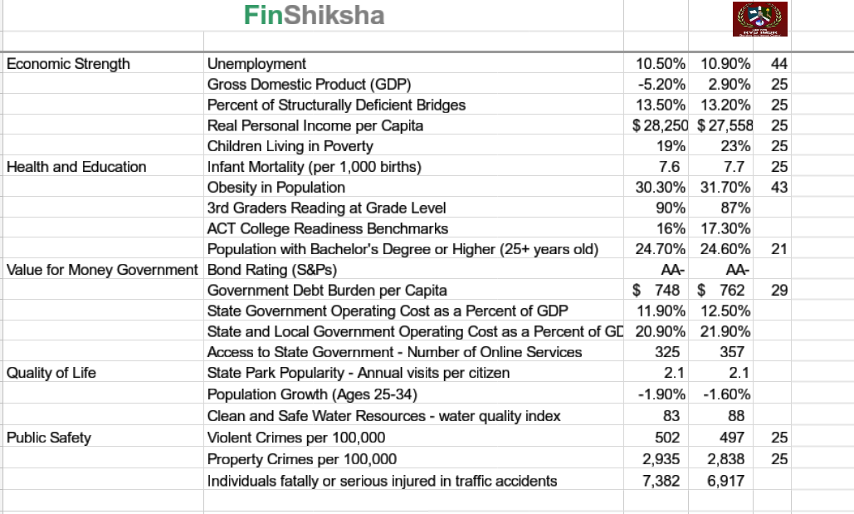

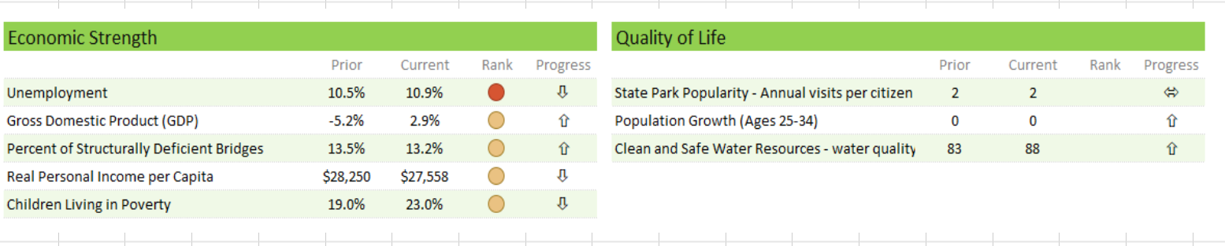

**Aim:** To create a Dashboard for the given data using MS – Excel.

**Step 1:** Open MS Excel by using the command start – All Programs – Microsoft office – MS Excel.

**Start -> All Programs -> Microsoft Office -> MS-Excel**.

**Step 2:** Create a separate sheet called Dashboard.

**Step 3:** Type the given area separately and type subtopics under each area.

**Step 4:** To copy the value of metric for Economic strength type formula asbelow

**=’Data Dashboard’! B5**

By using the above steps create separate table for each area and copy its metric value.

**Step 5:** To get the value of prior for each table, type formula as below:

**=VLOOKUP (metric value, ’Data Dashboard’! $B$5:$E$25, 2, 0)**

By using the given formula retrieve the value of prior for each metric.

**Step 6:** To get the value of current for each table, type formula as below:

**=VLOOKUP (Metric Value, ‘Data Dashboard’! $B$5: $E$25, 3, 0)**

**Step 7:** To get the value of Rank for each table, type formula as below:

**=VLOOKUP (Metric Value, ‘Data Dashboard’! $B$5:$E$25, 4, 0)**

**Step 8:** To find the value of progress type formula as below:

**= Current - Prior**.

By using the given formula retrieve the value of progress for each area.

**Step 9:** To set icons, select the Rank value do as follows,

**Home –> Conditional formatting –> Icon sets –> Shapes –> Circle.**

To set Icons, select the Progress and do as follows,

**Home –> Conditional formatting –> Icon sets –> Shapes –> Arrows.**

By using the above steps set Icons for Rank and Progress in each area.

**OUTPUT:**

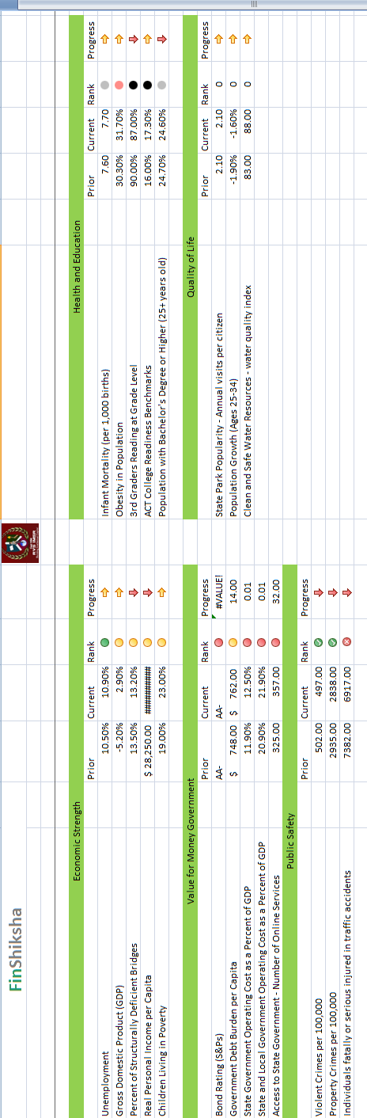

**EX.NO: 9**

**DATE:**

**Dashboard Creation using Company and Variable Cost**

**AIM:**

To create a dashboard for the following data: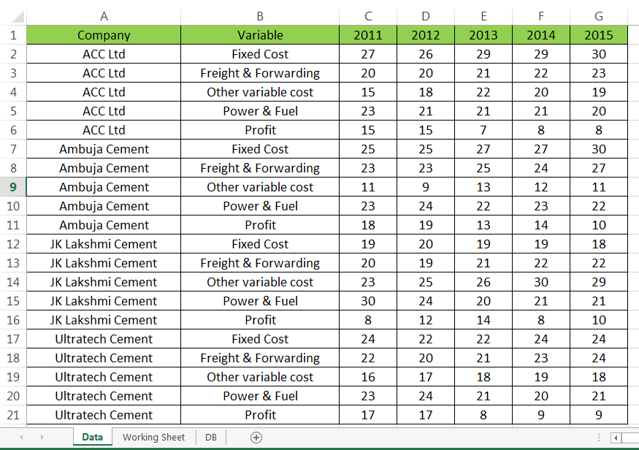

**ALGORITHM:**

**Step 1:** Open MS-EXCEL using the below menu:

**Start -> All Programs -> Microsoft Office -> MS-Excel**

**Step 2:** Enter the data in the Excel Sheet.

**Step 3:** Select the entire data and use the below menu to create the Pivot table in the working sheet:

**Insert -> Pivot Table**

**Step 4:** Select Company in the Filter option the Pivot table will be created.

**Step 5:** Now insert slicer using Analyze menu for company & variable fields

**Step 6**: Again create a pivot table for year wise data based on the company and variable cost

**Step 7**: For that select variable cost in filters, Company in Rows and Year 2011 data in Σ Values.

**Step 8:** Proceed with the same process for 2012, 2013, 2014 and 2015 data in the similar manner.

**Step 9:** The above things has been done in working sheet. Now we have to create a Dashboard Sheet and copy the Variable Cost Slicer and Company Slicers.

**Step 10:** Now use the Vlookup formula to get values from pivot table for each year for the Dashboard Sheet.

**Step 11:** After completing that process, we need to attach the variable cost slicer with the year 2011, 2012, 2013, 2014 and 2015 pivot tables. For that select the variable cost slicer then the Options menu has been enabled. From that Options menu, select the Report Connections, that will show the pivot tables created for year wise data. Click that check box and click Ok, then the Slicer will be connected with the Year wise Pivot tables and show the related data.

**Step 12**: Using the Conditional Formatting Techniques, we will highlight the selected company. This will be the expected result.

**OUTPUT:**



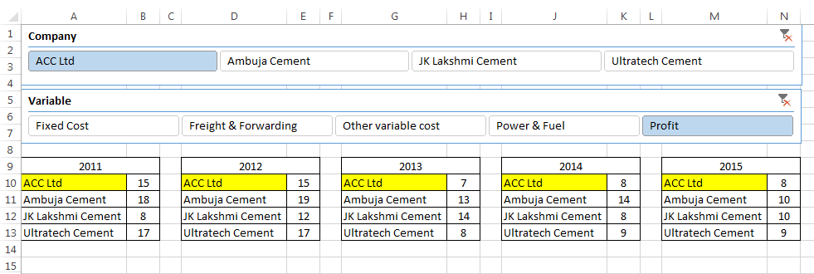

**EX.NO: 10**

**DATE:**

**DASHBOARD CREATION USING SLICER**

**Write down the complete steps to create a Dashboard for the below data:**

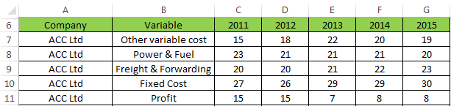

**Aim:** To Create a Dashboard for the given data using MS – Excel.

**Algorithm:**

**Step 1:** Open MS – Excel by using the command Start – All programs – Microsoft Office – MS-Excel.

**Start -> All Programs -> Microsoft Office -> MS-Excel**

**Step 2:** Type the given company field, Variable field, 2011, 2012, 2013, 2014, 2015 and its values.

**Step 3:** Create a Pivot Chart by selecting the value form **A6:A26** and click

**Insert –> Pivot Chart –> Pivot table –> Pivot chart.**

**Step 4:** Select new worksheet Radio button and click OK.

**Step 5:** Create Slicer for Company and variable by using the command select the below:

**Pivot table –> Analyze –> Insert slicer –> Enable company check box.**

**Step 6:** Create another pivot table for variable by using the command

**Insert – Pivot chart – Pivot table – Pivot chart.**

**Step 7:** Select Existing worksheet Radio Button select Location and click OK button.

**Step 8:** Create a slicer for variable by using the command select the variable

**Pivot table – Analyze – Insert slicer – Enable company check box.**

**Step 9:** Cut the slicers of Company and variable and paste it in a new sheet.

**Step 10:** Type 2011, 2012, 2013, 2014, 2015 as field names.

**Step 11:** Create a separate table for variable from O8 to O12 consists of Fixed Cost, Freight and Forwarding, Other variable cost, power and fuel, profit.

**Step 12:** To get the values for 2011 type formula as below:

**= OFFSET (INDEX (Data! $A$6:$A$25, MATCH (‘Workingsheet2’! $B$1, Data! $A$6:$A$25, 0),), MATCH (08, Data! $B$6:$B$25, 0)-1, 2)**

Use the same formula for all the columns, except the column number and variable reference. Change the column number to 3 when you drag and copy the formula to the next column and after O12, O8, O9, and O10. When you copy the formula to other rows.

**Step 13:** Now based on the selections in company and variable slicers, the value changes dynamically.

**Output:**

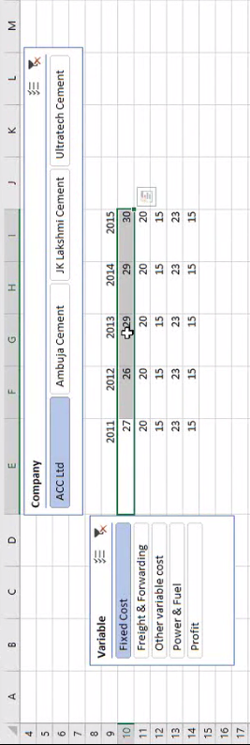

**EX.NO:11**

**DATE:**

**PERFORMING MATEMATICAL AND STATISTICAL CALCULATIONS USING MACRO**

**Create a macro called basic_math to perform mathematical functions like product, sum and Statistical measures like average and standard deviation of an Array using the below data:**

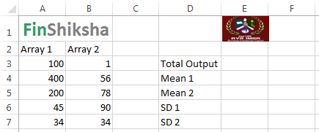

**Aim:** To create a macro called Basic_math to perform mathematical functions like Product, Sum, Average and Standard deviation of an array for the given data.

**Algorithm:**

**Step 1:** Open MS – Excel by using the command Start – All programs – Microsoft Office – MS-Excel.

**Start -> All Programs -> Microsoft Office -> MS-Excel**

**Step 2:** Type the given values of array1 and array2.

**Step 3:** To create a basic_math macro click the below:

**Developer tab –> Record Macro**

**Step 4:** Type the Macro name as Basic_math.

**Step 5:** Set a shortcut key like ctrl+L

**Step 6:** Set description and click OK button. Now your actions get recorded.

**Step 7:** Find the sum of two arrays by using the below function:

**= SUM (Array1, Array2)**

**Step 8:** To find Mean1, type formula as below:

**=AVERAGE (Array1)**

**Step 9:** To find Mean2, type formula as below:

**=AVERAGE (Array2)**

**Step 10:** To find the Total Output, type formula as below:

**=SUMPRODUCT (Array1, Array2)**

**Step 11:** To find SD1 type formula as below:

**=STDEV (Array1)**

**Step 12:** To find SD2 type formula as below:

**=STDEV (Array2)**

**Step 13:** To stop Macro recording, click Developer – Stop Macro.

**Step 14:** Now you can use the Basic_math macro to get the values whenever it’s needed.

**OUTPUT:**

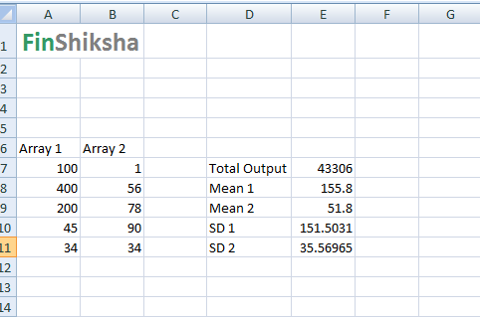

**EX.NO:12**

**DATE:**

**CALCULATE THE EMI USING MACRO**

Create a macro to calculate the EMI and repayment schedule for the below data:

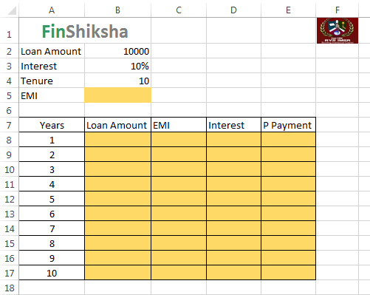

**Aim:** To Create a macro to calculate EMI and repayment schedule for the given data.

**Algorithm:**

**Step 1:** Open MS – Excel by using the command Start – All programs – Microsoft Office – MS-Excel.

**Start -> All Programs -> Microsoft Office -> MS-Excel**

**Step 2:** Type the given Loan amount, Interest, Tenure and its values.

**Step 3:** Type field names as years, Loan amount, EMI, Interest, p payment

**Step 4:** Create a Macro in the name of Amortization_Schedule.

**Step 5:** To create a Macro, click the below menu.

**Developer –> Record Macro.**

**Step 6:** Set Macro name as “Amortization_Schedule”, set a shortcut key and description, then click OK.

**Step 7:** To find EMI using the below formula:

**=PMT (Interest Rate, Tenure, -loan amount, 0)**

**Step 8:** Type 1 to 20 in year’s column.

**Step 9:** To find loan amount, type formula as below:

**=loan amount**

**Step 10:** To find EMI, type formula as below:

=PMT.

**Step 11:**  To calculate Interest type formula as below:

**=Interest rate * loan amount**

**Step 12:**  To calculate P.Payment, type formula as below:

**=EMI – Interest amount**

**Step 13:** To calculate loan amount for 2nd year, type formula as below:

**=1st year loan amount – P.Payment**

**Step 14:** To stop Macro recording, click

**Developer –> stop Macro.**

**OUTPUT:**

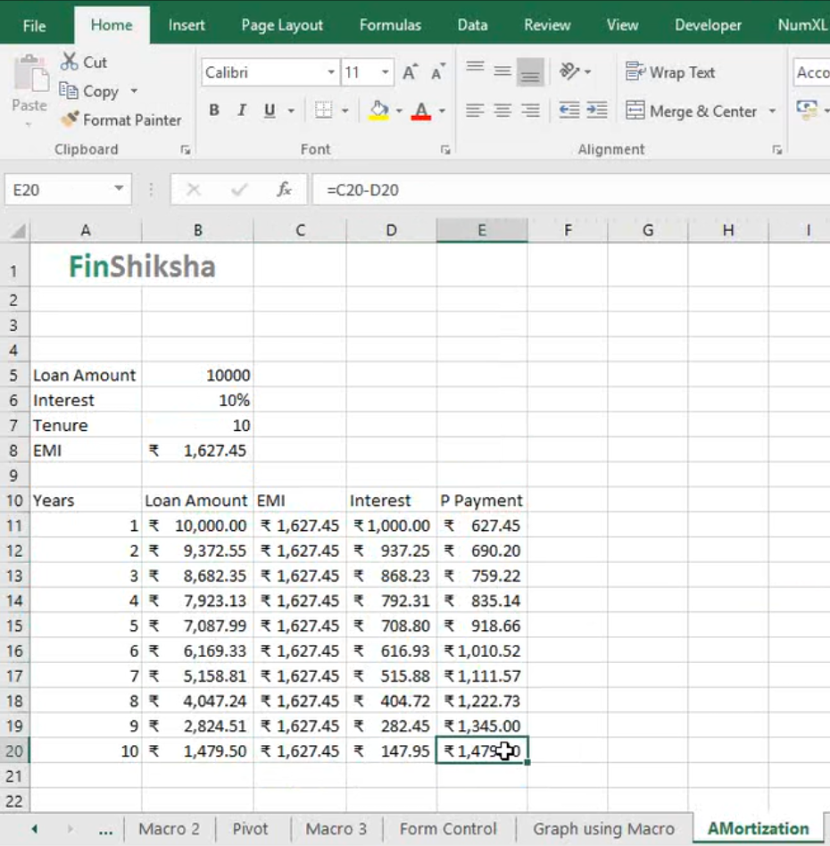

**EX.NO: 13**

**DATE:**

**Searching a String / Value using Macros**

**Aim: To search a given string / value from the list of values using Macros.**

**Algorithm:**

**Step 1:** Open MS-EXCEL by using the below menu:

**Start -> All Programs -> Microsoft Office -> MS-Excel**

**Step 2:** Enter the list of values in the excel sheet.

**Step 3:** Create a Command Button using the Developer Menu **and name it as “Find String”**

**Step 4:** Using the view Code option write the below VBA Code for searching a given string from a set of values.

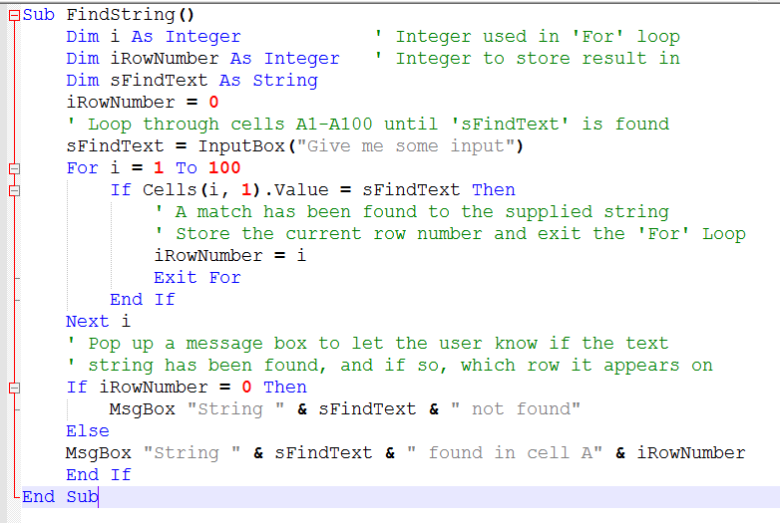

**Step 5:** Map this Function with the Command Button Find String and click on that button, the system will show a dialogue box and expect the input value which has to be search.

**Step 6:** Enter the input value and click Ok the system will check that value is available in the list of values. If that value found in the list, the system will show the cell address which the value will be present. Otherwise the system will show the message that the given input value is not present in the list.

**Step 7:** This is the expected output.

**OUTPUT:**

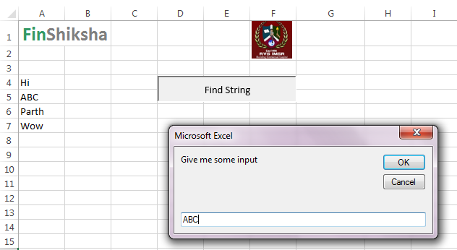

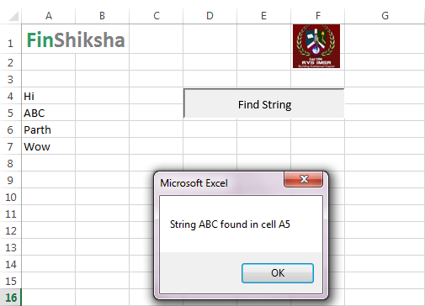

**EX.NO:14**

**DATE:**

**CALCULATING THE STATISTICAL MEASURES USING DATA ANALYSIS MENU**

**Calculate the Mean, Standard Deviation etc. mentioned in the below excel with the sample data:**

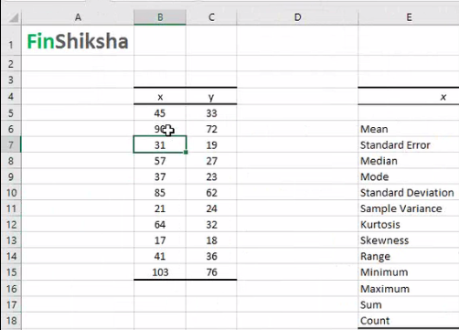

**Aim:**

To calculate statistical measures for the given data using MS – Excel.

**Algorithm:**

**Step 1:** Open MS – Excel by using the command Start – All programs – Microsoft Office – MS-Excel.

**Start -> All Programs -> Microsoft Office -> MS-Excel**.

**Step 2:** Type the given values of X and Y.

**Step 3:** To calculate Descriptive statistics for the given data, click the below:

**Data –> Data Analysis –> Descriptive Statistics**

**Step 4:** Select the values of X as Input range.

**Step 5:** Select output range and enable Summary statistics check box.

**Step 6:** Click OK Button. Now the output will be displayed in the selected Output range.

**OUTPUT:**

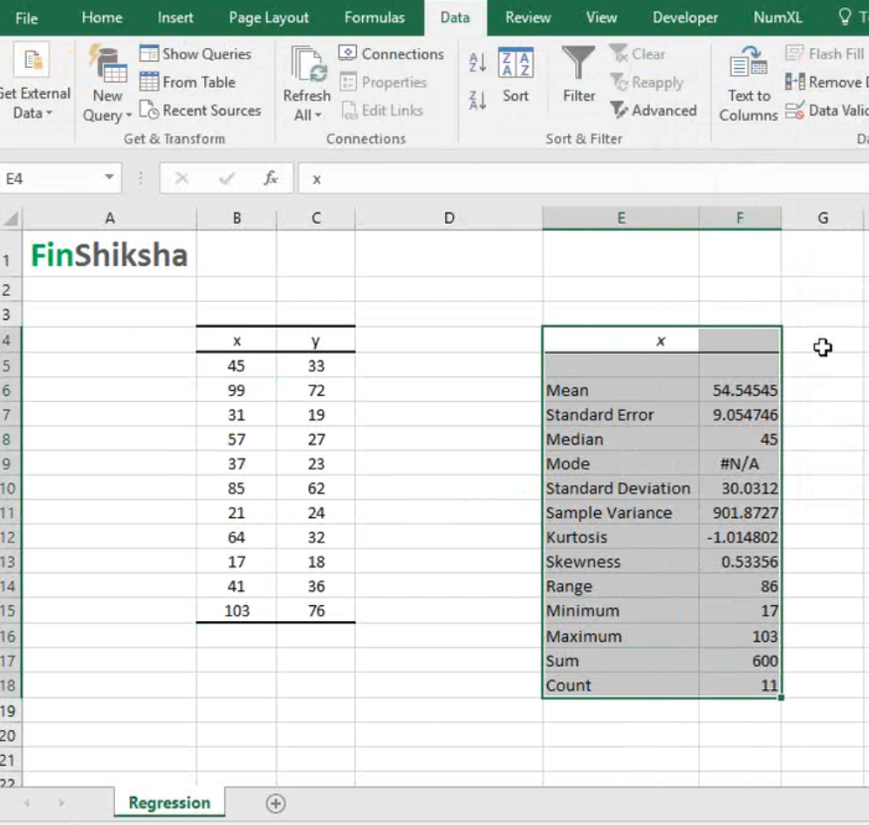

**EX.NO:15**

**DATE:**

**MULTIPLE REGRESSION**

**Calculate the Multiple Regression for the following data:**

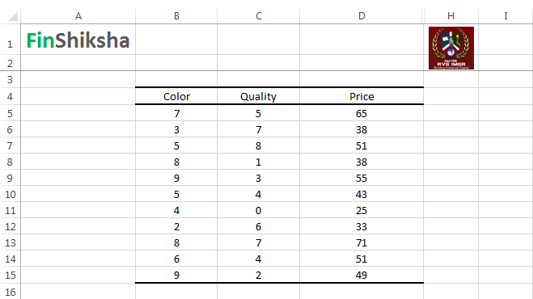

**Aim:**  To Calculate Multiple Regression for the given data using MS – Excel.

**Algorithm:**

**Step 1:** Open MS – Excel by using the command Start – All programs – Microsoft Office – MS-Excel.

**Start -> All Programs -> Microsoft Office -> MS-Excel**.

**Step 2:** Type the given Color, Quantity, Price fields and its values.

**Step 3:** To calculate multiple regression for the given data, click the below:

**Data -> Data Analysis -> Regression**

**Step 4:** We will get the dialogue box for providing the Input values as below:

**Input Y range : Select the Price Column Values**

**Input X range : Select the color and quantity column range values.**

**Step 5:** Check the Label check box if we are selecting the Color, Quality and Price column headings.

**Step 6:** Select Output range in the Same Sheet means, mention the Cell address.

**Step 7**: Select the Output range as New Worksheet, we will get the output in the new sheet.

**Step 8**: Select the Residual check box if we want to calculate the residual values.

**Step 9:** Click OK button, we will get the Statistical Summary, ANOVA and Residual Output.

**Step 10:** From this data we can get the Intercept and Coefficient of Color and Quantity variables.

**Step 11: Using** the Intercept, Coefficient of Color and Quantity variables we can compute the calculated value of Price. From the given price and the calculated Price we can measure the Residual values.

**Step 12**: From this we can identified the Best Fit Line values of Intercept and Coefficient of Color and Quantity variables can be identified.

**OUTPUT:**

